New Features of QTP 10.0
QuickTest 10.00 now offers the following new features. Click a link to view more details about the selected item.
- Centrally Manage and Share Testing Assets, Dependencies, and Versions in Quality Center 10.00
- Perform Single-User Local System Monitoring While Running Your Tests
- Improve Portability by Saving Copies of Tests Together with Their Resource Files
- Call Actions Dynamically During the Test Run
- Develop Your Own Bitmap Checkpoint Comparison Algorithm
- Centrally Manage Your Work Items and ToDo Tasks in the To Do Pane
- Improve Test Results Analysis with New Reporting Functionality
- Test Standard and Custom Delphi Objects Using the Delphi Add-in and Delphi Add-in Extensibility

1. Centrally Manage and Share Testing Assets, Dependencies, and Versions in Quality Center 10.00
QuickTest Professional 10.00 has a powerful set of new Quality Center 10.00 integration capabilities for QuickTest assets.*
These integration capabilities include:
- New resources and dependencies model for storing and managing shared assets
- Support for asset versioning and baselines
- Asset Comparison Tool for comparing versions of individual QuickTest assets and Asset Viewer for viewing an earlier version of a QuickTest asset
- A special tool for Quality Center administrators that upgrades all QuickTest assets to use these new features.
* QuickTest assets include tests, components, application areas, and the resources associated with them, such as shared object repositories, function libraries, recovery scenarios, and external data tables.

2. Perform Single-User Local System Monitoring While Running Your Tests
The new local system monitoring feature (File > Settings > Local System Monitor) enables you to monitor the local (client-side) computer resources used by the application instance you are testing during a run session.
You can monitor a number of different system counters to view the effects your application has on the system. You can also define upper limits for the counters. If any of the specified counters exceed these limits, the test run will fail.
Additionally, you can export the data from the System Monitor tab to a variety of file types.
The results generated for the counters you monitor are displayed as a line chart in a special System Monitor tab in the Test Results window.
The System Monitor tab in the Test Results window
The points in the chart are synchronized with the steps in the Run Results tree. When you select a step in the tree, the (red) Current Step line jumps to the corresponding location in the chart.
You can also export the data from the chart so it can be further analyzed in other programs.
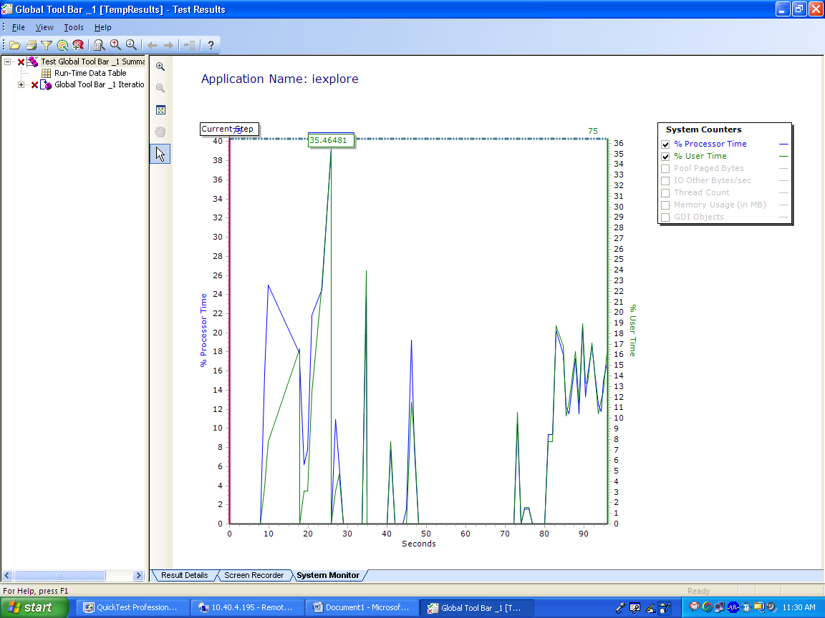

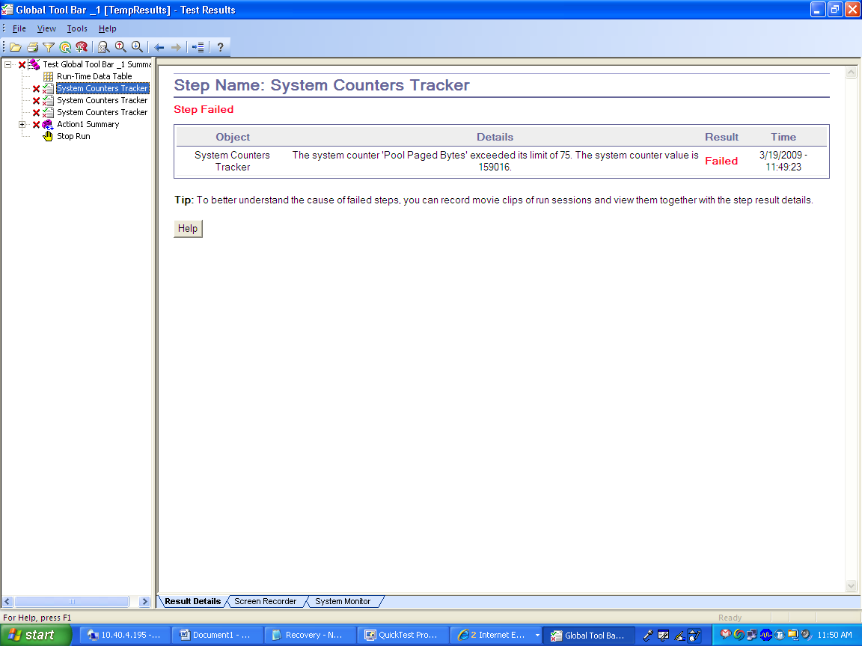

3. Improve Portability by Saving Copies of Tests Together with Their Resource Files
Tests and their resource files are often stored on a network drive or in Quality Center. However, you may need to open or run a test when you do not have access to the network drive or Quality Center. For example, you may need to create a portable copy of a test for use when travelling to other sites.
You can save a standalone copy of your test and its resource files to a local drive or to another storage device using the File > Save Test with Resources command. When you save a test in this manner, QuickTest creates a copy of your test, all associated resource files, and any called actions.

4. Call Actions Dynamically During the Test Run
Generally, when you insert a call to an external action, the action call becomes part of the test, and the called action is loaded each time you open the test.
In some situations, you may want to take advantage of the new LoadAndRunAction statement to load an action only when the step runs, and then run that action.
This is useful, for example, if you use many conditional statements that call external actions, and you do not want to load all of these actions each time you open the test, since these actions may not be necessary during the run session.

5. Develop Your Own Bitmap Checkpoint Comparison Algorithm
You (or a third party) can now develop custom comparers for bitmap checkpoints. A custom comparer is a COM object that performs the bitmap comparison for the checkpoint according to your testing requirements. For example, you could define a custom comparer that allows a bitmap checkpoint to pass even if the image in the application shifts by an amount specified when the checkpoint is defined.
After you install and register a custom comparer on the QuickTest computer, your comparer is available for selection in the Bitmap Checkpoint Properties dialog box. The dialog box provides space for specifying additional configuration preferences expected by your comparer.
When QuickTest performs a bitmap checkpoint that uses a custom comparer, it supplies the expected and actual bitmaps to the custom comparer object. It then receives and reports the results that the custom comparer returns.
For information on how to create custom comparers, see the Bitmap Checkpoint Customization appendix of the HP QuickTest Professional User Guide in the QuickTest 10.00 Help.

6. Centrally Manage Your Work Items and ToDo Tasks in the To Do Pane
The new To Do pane that is now available in the QuickTest IDE, enables you to create and manage self-defined tasks, and to view a compiled set of the TODO comments from your tests, components, and associated function libraries.
For example, you can use the Tasks tab to provide instructions to someone else during a handover, or to create reminders for yourself. The Tasks tab provides check boxes in which you can mark off each task as you complete it. In the Comments tab, you can view and sort all your TODO comments. You can also jump directly to a selected TODO comment in the testing document.
To Do Pane: Tasks View
If you use the Maintenance Run Wizard to detect updates needed to your steps or object repository, then you can use the To Do pane to track and manage the TODO comments added during the maintenance run session.
You can also export your tasks and TODO comments from the To Do pane to an XLS (Excel), CSV (comma separated), or XML file.
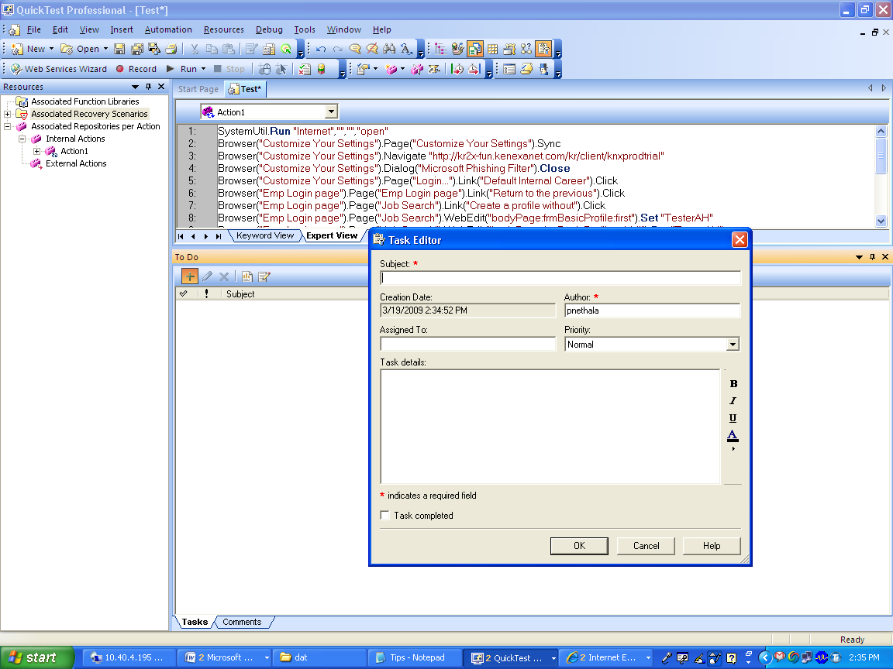

7. Improve Test Results Analysis with New Reporting Functionality
QuickTest 10.00 includes a powerful set of new reporting options that help you analyze and manage your run results more thoroughly and efficiently. These include:
- Jump to step. When you want to know more about a particular node in the Test Results window, right-click it and select Jump to Step in QuickTest. The QuickTest main window comes into focus, and the cursor jumps to the relevant step.
- Export Test Results to Microsoft Word or PDF Formats. In addition to HTML format, you can now select to save your QuickTest run results in Microsoft Word or PDF formats. You can then share this information, together with any local system monitoring data, with your developers and performance testing teams.
- New Image Reporting Options:
  - Add Images to the Test Results. When you use the Reporter.ReportEvent method to add information to the run results, you can now specify an image file as the fourth argument. When you view the results, the image is displayed in the Result Details tab of the Test Results window. For example, you can include an image returned by a CaptureBitmap step in the run results.
  - View Bitmaps Differences in Bitmap Checkpoints. In addition to the expected and actual bitmaps that are displayed in the Test Results window, you can also select to view the differences between the two. The difference bitmap is a black-and-white image that contains one black pixel for every pixel that is different between the two images.
  - Include Images in Exported and Printed Test Results. When you choose the Detailed option for printing or exporting, the document now includes all images. These include screen captures of steps, expected, actual, and difference bitmaps for bitmap checkpoints, and any images sent to the run results using the ReportEvent method.
- Additional Quality Center Details. The run results for tests and components that are run as part of a Quality Center test set now include the Quality Center server and project name. For more information,

8. Test Standard and Custom Delphi Objects Using the Delphi Add-in and Delphi Add-in Extensibility
The new Delphi Add-in enables you to test Delphi controls that were created in the Delphi IDE and are based on the Win32 VCL library.
QuickTest Professional Delphi Add-in Extensibility is an SDK (Software Development Kit) package that enables you to develop support for applications that use third-party and custom Delphi controls that are not supported out-of-the-box by the QuickTest Professional Delphi Add-in.

2. Product Enhancements
QuickTest now offers the following product and feature enhancements. Click a link to view more details about the selected item.
- Upgrade from QuickTest 9.5
- Improved IntelliSense Functionality
- Added Control for Editing and Managing Actions in Automation Scripts
- Improved Debugger Pane Design and Functionality
- New Object Identification Solutions in Maintenance Run Mode
- Additional Configuration Settings for Text Recognition Mechanism
- New Look for Options, Settings, and File Dialog Boxes
- QuickTest Toolbar Customization Options
- Improved Web Extensibility
- .NET Add-in and Extensibility Improvements
- New Terminal Emulator Configuration Validation

1. Upgrade from QuickTest 9.5
If QuickTest 9.5 is installed on your computer, you can choose to upgrade to QuickTest version 10.00. This enables you to continue using many of the configurations and options you already set in QuickTest 9.5. You can also use an msi silent installation command line to upgrade from QuickTest 9.5.

2. Improved IntelliSense Functionality
QuickTest now provides full IntelliSense for the following types of objects:
- Objects created by a step or function (for example, by calling the CreateObject method)
- Variables to which an object is assigned
- Reserved objects
- COM objects
- Properties that return objects
In addition:
- IntelliSense sentence completion now provides lists of local variables.
- Multi-level IntelliSense information is available for all reserved objects, COM objects, and objects created using the CreateObject method. For example, method names and available properties are offered for each item in the statement below:
attr_count = XMLUtil.CreateXML.ChildElementsByPath ("").ItemByName ("abc").Attributes.Count

3. Added Control for Editing and Managing Actions in Automation Scripts
The QuickTest Professional Automation Object Model has a new set of objects and methods for manipulating test actions and action parameters. You can now use automation scripts to create new actions, modify and validate the syntax of action scripts, create and modify action parameters, and more.

4. Improved Debugger Pane Design and Functionality
The Debug Viewer pane has a new look, including icons to help you identify the type of information displayed.
The Watch tab and Variable tab now display the types of expressions or variables, in addition to their names and values.
The Command tab now displays the command history (in read-only format) in addition to the command line, enabling you to view previously-run commands and select commands to reuse.
In addition, a right-click context menu in the Command tab enables you to:
- Copy from the command history and edit the command line using the clipboard.
- Clear the command history.

5. New Object Identification Solutions in Maintenance Run Mode
In addition to helping you update your steps and object repositories when objects in your application change, the Maintenance Run Wizard can now help you solve the following problems:
- The step failed because the object in your test is missing from the action's associated object repositories.
- The object in your step exists in the application, but can be identified only through Smart Identification.

6. Additional Configuration Settings for Text Recognition Mechanism
You can now set all text recognition configuration settings from the QuickTest Options Dialog Box (Tools > Options > General > Text Recognition), including new options for selecting the text block mode and specifying the languages to be used with the OCR mechanism. This makes it easier to make any necessary adjustments and to optimize the way that QuickTest identifies text in your application.

7. New Look for Options, Settings, and File Dialog Boxes
The QuickTest Options and Settings dialog boxes have changed from their former tab-based design to a more easily navigable tree-based structure. The tree contains only the options relevant for the add-ins that are currently loaded.
The Test Settings dialog box with the Web and Java Add-ins loaded.
QuickTest file dialog boxes such as the New, Open, and save dialog boxes, now include a sidebar for quickly switching between the file system and Quality Center and for switching between various Quality Center resources storage locations.
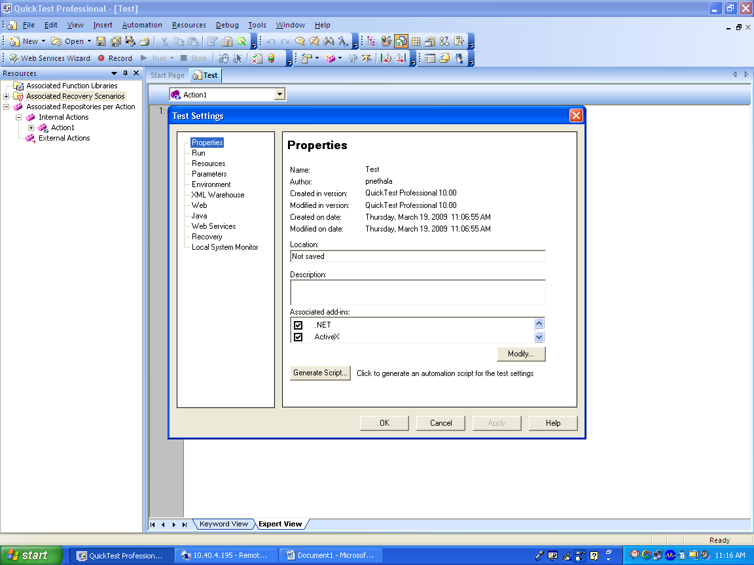

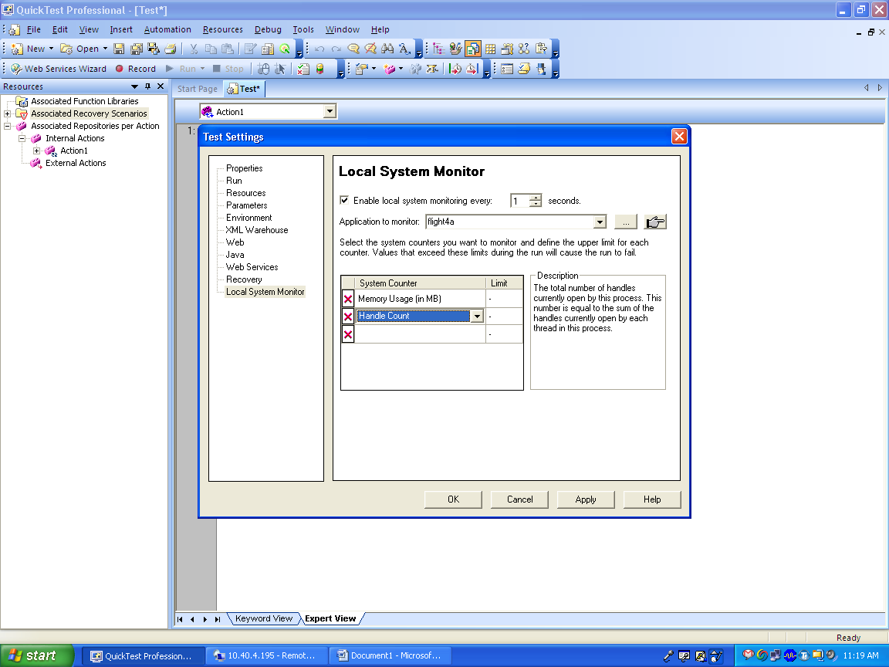

8. QuickTest Toolbar Customization Options
You can use the new Customize Dialog box (Tools > Customize) to customize the appearance of existing menus and toolbars, and to create your own user-defined menus, toolbar buttons, and shortcuts.
You can also add new commands to the QuickTest Tools menu so that you can launch an application directly from the menu. For example, you can use this option to create a shortcut to the application you want to test or to an automation script.

9. Improved Web Extensibility
QuickTest Professional Web Add-in Extensibility enables you to develop packages that provide high-level support for third-party and custom Web controls that are not supported out-of-the-box by the Web Add-in.
Limited extensibility support for the ASP .NET AJAX Control toolkit is provided with the extensibility installation. You can use this package as an example for reference or as a basis for your own Ajax extensibility packages.
By creating support for a Web control using Web Add-in Extensibility, you can direct QuickTest to recognize the control as belonging to a specific test object class. You can also extend the list of available test object classes that QuickTest is able to recognize and the list of operations that are available for each class. This enables you to create tests that fully support the specific behavior of your custom Web controls.
The QuickTest Professional Web Add-in Extensibility SDK 10.00 offers the following improvements:
- The Web Add-in Extensibility SDK now provides a global object, window, that you can use in your JavaScript code to access the Internet Explorer global namespace. This enables you to access client-side JavaScript objects and functions in the application you are testing.
- You can now use the Microsoft Script Debugger or the Microsoft Visual Studio debugger to debug JavaScript code that you write for Web Add-in Extensibility.
- The LogLine method provided by the _util object can now (optionally) accept a numeric ID and a numeric Category for the log entry that it passes to the event log. Users can later use this information to filter log entries in the Event Viewer. In addition, the LogLine method can now accept string values for the severity argument, in addition to numeric values.

10. .NET Add-in and Extensibility Improvements
The .NET Add-in provides the following new objects and methods:
- The .NET Add-in now supports learning, recording, and running on .NET Windows Forms property grids. QuickTest learns these controls using the new SwfPropertyGrid test object class.
- The .NET Add-in has a new GetErrorProviderText method and ErrorProviderText identification property, which is supported for all .NET Windows Forms test objects. You can use this method or property to retrieve the tooltip text of the error icon associated with the object.
.NET Add-in Extensibility includes the following enhancements:
- The C# and Visual Basic project templates and wizards provided with the .NET Add-in Extensibility SDK installation are now provided on Microsoft Visual Studio 2008 (as well as on Microsoft Visual Studio .NET and Microsoft Visual Studio 2005).
- .NET Add-in Extensibility now enables users to create support for table checkpoints on custom .NET Windows Forms table controls.
For more information, see the HP QuickTest Professional .NET Add-in Windows Forms Extensibility Help (accessible from the QuickTest Professional > Extensibility > Documentation program group in the Start menu).

11. New Terminal Emulator Configuration Validation
The Terminal Emulator pane of the Options dialog box now includes a Validate button. When you click this button, QuickTest checks the current configurations of the selected emulator. If a problem is detected, a brief description is displayed in the pane. You can also click the Troubleshoot button to view a Help page that provides additional information about the detected problem.

3. New Supported Operating Systems and Environments
QuickTest Professional 10.00 now offers support for the operating systems, browsers, and development environments listed below.
- Microsoft Windows 2008 Server 32-bit Edition
- Microsoft Windows 2008 Server 64-bit Edition
- Microsoft Windows Vista, Service Pack 1, 32-bit Edition
- Microsoft Windows Vista, Service Pack 1, 64-bit Edition
- Microsoft Windows XP Professional 32-bit Edition—Service Pack 3
- Citrix Presentation Server 4.5
- Microsoft Internet Explorer 8, Beta 2
- Mozilla Firefox 3.0.x
- Delphi: IDE, versions 6, 7, and 2007 (for controls based on the Win32 VCL library)
- SAP: CRM 2007 (For controls that support test mode enhancements. Requires SAP notes: 1147166, 1066565, and 1002944. Later SAP notes related to test mode enhancements are not supported.)
- Java: IBM 32-bit JDK 1.5.x, SWT toolkit version 3.4
- Java Extensibility: Eclipse IDE 3.4
- .NET: .NET Framework 3.5—Service Pack 1

4. Some More info
1.

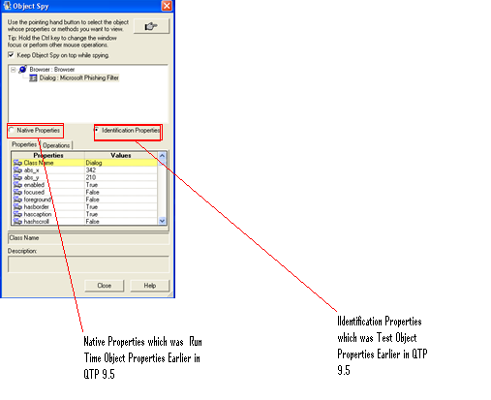
2. RefreshObject (): Instructs Quick Test to re-identify the object in the application the next time a step refers to this object.
(This is added new to the Object Spy which will handle Ajax Objects on the page.)
3. NEW!! Business components associated with an application area use only the resources and settings that are defined in the application area. In previous versions of QuickTest Professional, business components could have custom settings.
4. NEW!! You can manage the availability of keywords used to create keyword-driven components using the new Keywords pane in the application area of QuickTest Professional.
5. NEW!! You can check syntax errors by clicking CTRL + F7. If your script contains errors you can view them in the new Information pane.
6. NEW!! You can copy the content of the Documentation column to the Clipboard by right-clicking any column header in the Keyword View and choosing Copy Documentation to Clipboard.
7. NEW!! You can export object repository content to an XML file and import a new object repository from an XML file.

